**Tops Groceries Database**

**Final Project**



CMPT 308

Sec 902

Jozef Gjidoda

Dr. Schwartz

11/21/2021

**Table of Contents**

**Database Description**...............................................................................................................................4

**Chen Entity Relationship Diagram**......................................................................................................6

**Tables**..........................................................................................................................................................7

XAward............................................................................................................................................7

XBrand.............................................................................................................................................8

XCelebrity........................................................................................................................................9

XCondiment...................................................................................................................................10

XCreatedWith................................................................................................................................11

XFlavor..........................................................................................................................................12

XFoundAt......................................................................................................................................13

XIngredient....................................................................................................................................14

XMadeBy.......................................................................................................................................15

XSauce...........................................................................................................................................16

XStore............................................................................................................................................17

XUsed............................................................................................................................................18

**Queries**......................................................................................................................................................19

Query 1...........................................................................................................................................19

Query 2...........................................................................................................................................20

Query 3...........................................................................................................................................21

Query 4...........................................................................................................................................22

Query 5...........................................................................................................................................23

Query 6...........................................................................................................................................24

Query 7...........................................................................................................................................25

Query 8...........................................................................................................................................26

Query 9...........................................................................................................................................27

Query 10.........................................................................................................................................28

**Description**

A Tops Grocery store just opened in your local town. Unfortunately, with new employees, they seem to struggle to remember things about certain items. Especially condiments sold at the store. They are in need of a simple system that gives some hard and some fun facts about all the condiments they sell, and where it can be found in the stores around the country. The system must satisfy the following requirements:

1. There are tons of **condiments** on the shelves. Each condiment has a unique condiment number, along with name, the year it was discovered/made, inventors name, and calories per serving. Each condiment also:
   1. is **made by** many **brands** and has a price for the brand it is sold by..
   2. has one a **celebrity** it is favorited by the most.
   3. has many different condiment **flavors**
   4. can be **found at** many other top **store** locations and has an isle for the store it is sold in.
   5. can be **used** in many **sauces**
   6. are **created with** many **ingredients**.
2. The celebrities have a unique celebrity ID, along with their name, favorite condiment, favorite sauce, and the city of the local top's location they normally shop at.
3. Brands have unique brand numbers that identify them. They include their name, headquarters location, and owner. They also have one or more **awards** that they received.
4. Awards have a unique ID for each award, along with the name and year it was given out. Each award has only one brand that received that award, that specific year.
5. Tops stores are uniquely identified by their tops ID. Each Tops store has their city, state, and zip. There are many condiments that are sold at the store locations as well.
6. Sauces are identified by a sauce number. It also has the sauce names, and the calories of the sauce. There are many condiments used in a sauce.
7. Ingredients are identified by their unique ingredient numbers. The ingredients have various main ingredients that are used to make certain condiments. Each ingredient can also be used in one or more condiments.

**Chen Entity Relationship Diagram**

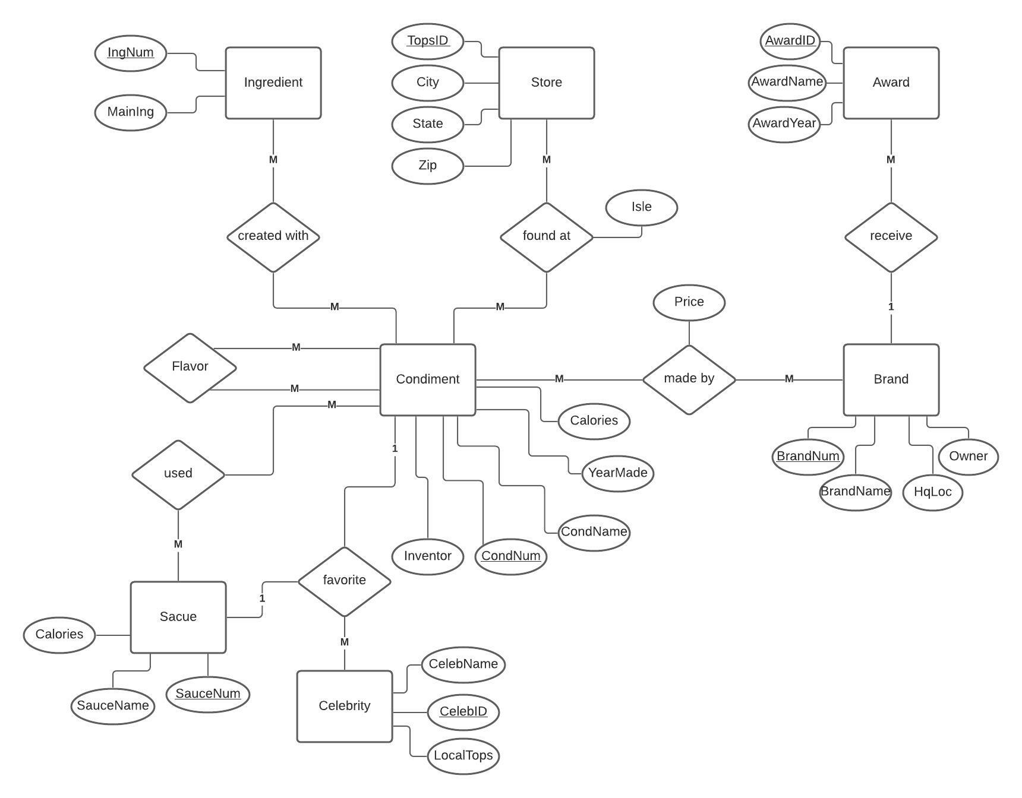

**Tables**

**xAward**

|  |  |  |  |
| --- | --- | --- | --- |
| AwardID | AwardName | AwardYear | BrandNum |

**PK**: {AwardID}

**FK**: {BrandNum} references xBrand

CREATE TABLE xAward (

AwardID INT NOT NULL PRIMARY KEY,

AwardName VARCHAR(45),

AwardYear INT,

BrandNum INT REFERENCES xBrand(BrandNum)

);

Description:

xAward table gives the award name, and year that a brand has won. It also gives future awards that brands haven't won yet. It uses BrandNum to link the two table together. There is no need for a bridge table because Brand to Award has a one to many relationship, and there is only one brand that can win that specific award

Third Normal Form: xAward is in third normal from shown here because there are no repeating groups. As well as no partial and transitive dependencies.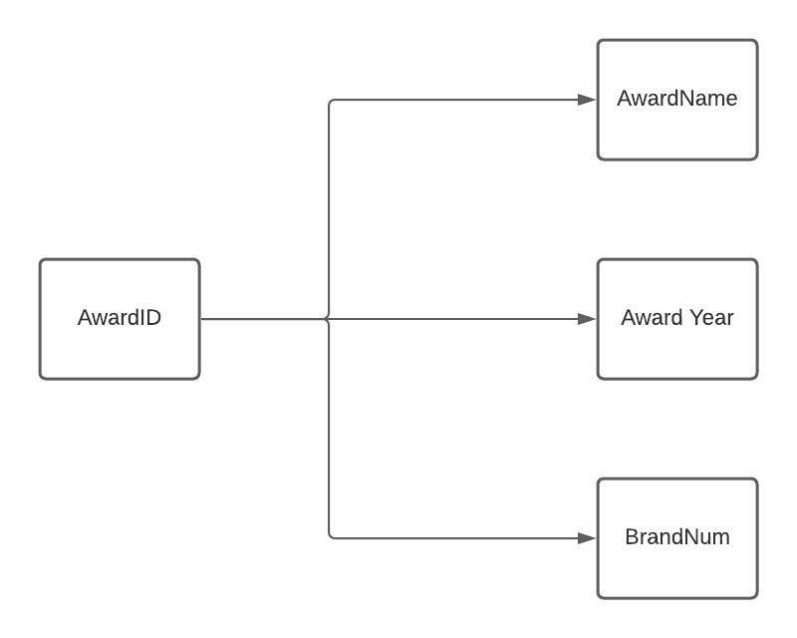 This table allows xBrand to be in third normal form by eliminating repeating brand with multiple awards.

**xBrand**

|  |  |  |  |
| --- | --- | --- | --- |
| BrandNum | BrandName | HqLoc | Owner |

**PK**: {BrandNum}

**FK**: N/A

CREATE TABLE xBrand (

BrandNum INT NOT NULL PRIMARY KEY,

BrandName VARCHAR(45);

HqLoc VARCHAR(45),

Owner VARCHAR(45)

);

Description:

xBrand table provides the different brands condiments can have. Specifically giving the brand name, head quarter location, and owner. It is linked to xAward through its primary key, BrandNum. It is also linked to xCondiments with a the bridge table xMadeBy, also using BrandNum.

Third Normal Form:

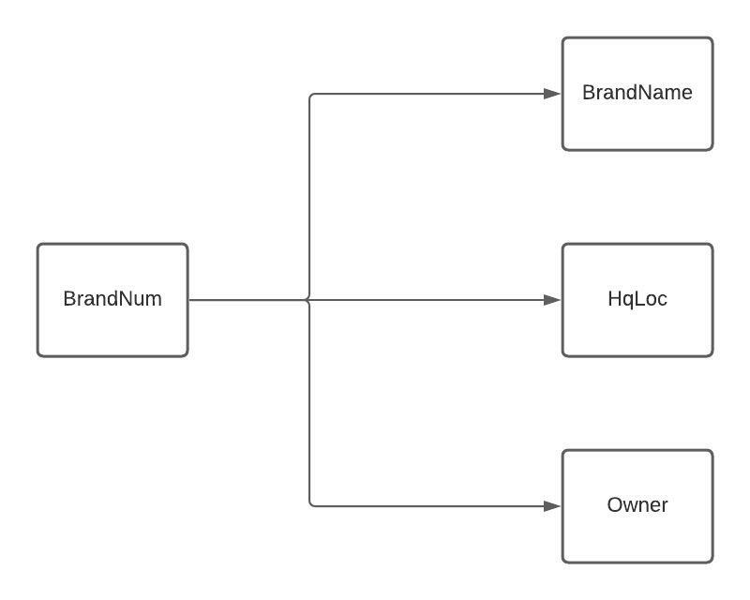xBrand is in third normal form shown here because it has no repeating groups. As well as no partial or transitive dependencies. It also allows for xCondiment to be in third normal form by eliminating repeating condiments made by different brands and both the dependencies.

**xCelebrity**

|  |  |  |  |  |
| --- | --- | --- | --- | --- |
| CelebID | CelebName | LocalTops | FavCond | FavSauce |

**PK**: {CelebID}

**FK**: {FavCond} references {CondNum} in xCondiment

{FavSauce} references {SauceNum} in xSauce

CREATE TABLE xCelebrity (

CelebID INT NOT NULL PRIMARY KEY,

CelebName VARCHAR(45),

LocalTops VARCHAR(45),

FavCond INT REFERENCES xCondiment(CondNum),

FavSauce INT REFERENCES xSauce(SauceNum)

);

Description:

xCelebrity table provides information on famous celebrities. It specifically gives their name, local Tops they shop at, and their favorite condiment and sauce. It is linked to xCondiment and xSauce using FavCond and FavSauce as CondNum, and SauceNum. It also has a one-to-many relationships with them both.

Third Normal Form: xCelebrity is in third normal form shown here because it has no repeating groups. As well as no partial or transitive dependencies.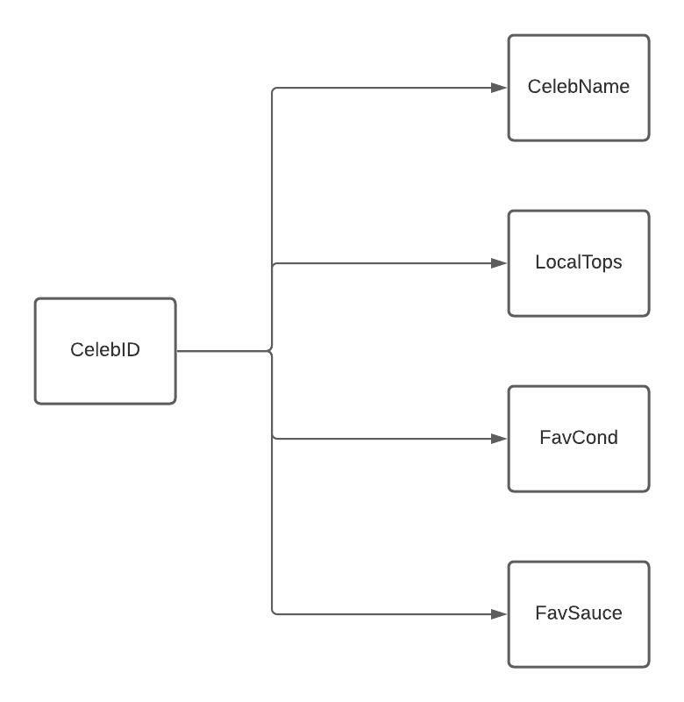 It also allows xCondiment to be in third normal for by eliminating repeating condiments favorites by the same celebrity.

**xCondiment**

|  |  |  |  |  |
| --- | --- | --- | --- | --- |
| CondNum | CondName | Inventor | YearMade | CalPerServ |

**PK**: {CondNum}

**FK**: N/A

CREATE TABLE xCondiment (

CondNum int NOT NULL PRIMARY KEY,

CondName VARCHAR(45),

Inventor VARCHAR(45),

YearMade INT,

CalPerServ INT

);

Decription:

xCondiment table provides information on common condiments. It specifically gives the condiment name, inventor, year it was made, and calories per serving. This table is also linked with xFlavor, xCelebrity, xSauce through xUsed, xIngredient through xCreatedWith, xStore through xFoundAt, and xBrand through xMadeBy.

Third Normal Form: xCondiment is in third normal form shown here because it has no repeating groups. As well as no partial or transitive dependencies.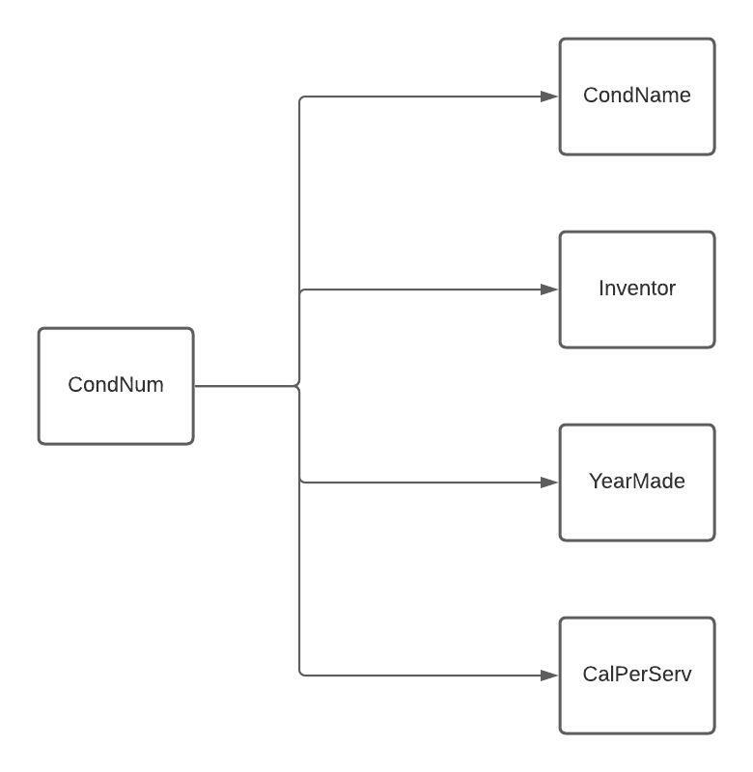

**xCreatedWith**

|  |  |
| --- | --- |
| CondNum | IngNum |

**PK**: {CondNum, IngNum}

**FK**: {CondNum} references xCondiment

{IngNum} references xIngredient

CREATE TABLE xCreatedWith (

CondNum INT REFERENCES xCondiment(CondNum),

IngNum INT REFERENCES xIngredient(IngNum)

);

Description:

xCreatedWith is a bridge table. It is used to link table xCondiment with xIngredient using CondNum and IngNum.

Third Normal Form:

This table is what allows xCondiment and xIngredient to be in third normal form by eliminating repeating groups and partial and transitive dependencies..

**xFlavor**

|  |  |
| --- | --- |
| CondNum | FlavorNum |

**PK**: {CondNum, FlavorNum}

**FK**: {CondNum} references xCondiment

{FlavorNum} references {CondNum} in xCondiment

CREATE TABLE xFlavor (

CondNum INT REFERENCES xCondiment(CondNum),

FlavorNum INT REFERENCES xCondiment(CondNum)

);

Description:

xFlavor is a bridge table. It is used to link tables condiments with its flavor. The condiment and flavor have a recursive relationship.

Third Normal Form:

xFlavor allows xCondiment to be in third normal form by eliminating repeating condiments with multiple different flavors.

**xFoundAt**

|  |  |  |
| --- | --- | --- |
| CondNum | TopsID | Isle |

**PK**: {CondNum, TopsID}

**FK**: {CondNum} references xCondiment

{TopsID} references xStore

CREATE TABLE xFoundAt (

CondNum INT REFERENCES xCondiment(CondNum),

TopsID INT REFERENCES xStore(TopsID),

Isle INT

);

Description:

xFoundAt is a bridge table. It is used to link xCondiment, and xStore using CondNum and TopsId. It also provides the isle certain condiments can be found at certain Tops locations.

Third Normal Form:

xFoundAt allows xCondiment and xStore to be in third normal form by eliminating repeating condiments sold on certain isles at different stores and partial and transitive dependencies.

**xIngredient**

|  |  |
| --- | --- |
| IngNum | MainIng |

**PK**: {IngNum}

**FK**: N/A

CREATE TABLE xIngredient (

IngNum INT NOT NULL PRIMARY KEY,

MainIng VARCHAR(45)

);

Description:

xIngredient table provides the main ingredients of each condiment. It uses xCreatedWith to link to xCondiment with IngNum because there can be many ingredients that are in many condiments.

Third Normal Form:

xIngredient is in third normal form shown here because it has no repeating groups. As well as no partial or transitive dependencies. It allows xCondiments to be in third normal form by eliminating repeating condiments with different ingredients.

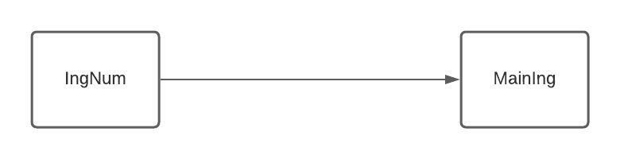

**xMabeBy**

|  |  |  |
| --- | --- | --- |
| CondNum | BrandNum | Price |

**PK**: {CondNum, BrandNum}

**FK**: {CondNum} references xCondiment

{BrandNum} references xBrand

CREATE TABLE xMadeBy (

CondNum INT REFERENCES xCondiment(CondNum),

BrandNum INT REFERENCES xBrand(BrandNum),

Price DEC(3,2)

);

Description:

xMadeBy is a bridge table. It is used to link xCondiment and xBrand using CondNum and BrandNum.

Third Normal Form:

xMadeBy allows xCondiment and xBrand to be in third normal form by eliminating repeating condiments with different prices for each brand and partial and transitive dependencies.

**xSauce**

|  |  |  |
| --- | --- | --- |
| SauceNum | SauceName | Calories |

**PK**: {SauceNum}

**FK**: N/A

CREATE TABLE xSauce (

SauceNum INT NOT NULL PRIMARY KEY,

SauceName VARCHAR(45),

Calories INT

);

Description:

xSauce table provides sauces that combinations of ingredients can make. It specifically gives the name and how many calories per serving it is and is linked to xCondiment through xUsed, and xCelebrity using SauceNum.

Third Normal Form:

xSauce is in third normal form shown here because it has no repeating groups. As well as no partial or transitive dependencies. It also allows xCondiment to be in third normal form by eliminating repeating condiments that make different sauces and partial and transitive dependencies.

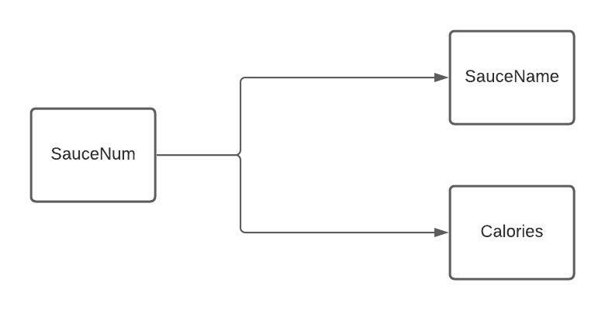

**xStore**

|  |  |  |  |
| --- | --- | --- | --- |
| TopsID | City | State | Zip |

**PK**: {TopsID}

**FK**: N/A

CREATE TABLE xStore (

TopsID INT NOT NULL PRIMARY KEY,

City VARCHAR(45),

State VARCHAR(45),

Zip INT

);

Description:

xStore table provides different Tops locations that certain condiments can be found at. It specifically gives the city, state and zip of each location, and is linked to xCondiment through xFoundAt using TopsID.

Third Normal Form: xStore is in third normal form shown here because it has no repeating groups. As well as no partial or transitive dependencies.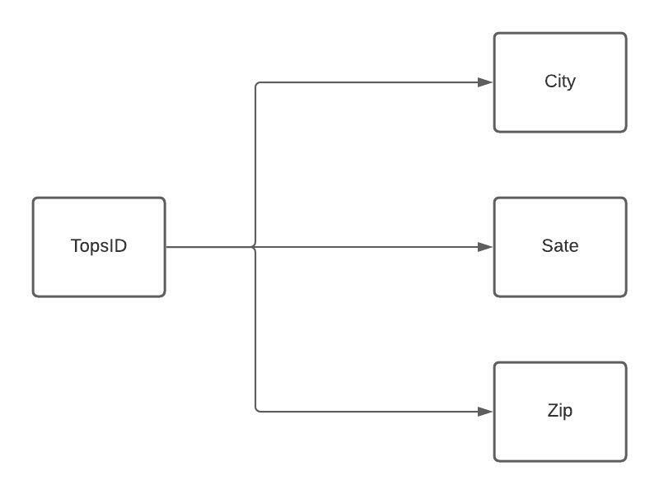 It also allows xCondiment to be in third normal form by eliminating repeating condiments with multiple stores and partial and transitive dependencies.

**xUsed**

|  |  |
| --- | --- |
| CondNum | SauceNum |

**PK**: {CondNum, SauceNum}

**FK**: {CondNum} references xCondiment

{SauceNum} references xSauce

CREATE TABLE xUsed (

CondNum INT REFERENCES xCondiment(CondNum),

SauceNum INT REFERENCES xSauce(SauceNum)

);

Description:

xUsed table is a bridge table. It is used to link xCondiment and xSauce using CondNum and SauceNum.

Third Normal Form:

xUsed allows xCondiment and xSauce to be in third normal form by eliminating repeating condiments that make multiple different sauces and partial and transitive dependencies.

**Queries**

**FinalQuery1:**

Get ingredients that appear in every condiment.

SQL:

SELECT ING.MAINING

FROM XINGREDIENT ING

WHERE NOT EXISTS

(SELECT CON.*

FROM XCONDIMENT CON

WHERE NOT EXISTS

(SELECT CW.*

FROM XCREATEDWITH CW

WHERE CW.CONDNUM = CON.CONDNUM

AND CW.INGNUM = ING.INGNUM));

Table:

|  |
| --- |
| **MAINING** |
| Salt |

Cardinality: 1

**FinalQuery2:**

Get brands that only ship wasabi.

SQL:

SELECT BR.BRANDNAME

FROM XBRAND BR

WHERE BR.BRANDNUM NOT IN

(SELECT MB.BRANDNUM

FROM XMADEBY MB

WHERE MB.CONDNUM NOT IN

(SELECT CON.CONDNUM

FROM XCONDIMENT CON

WHERE CON.CONDNAME = 'Wasabi'));

Table:

|  |
| --- |
| **BRANDNAME** |
| Kikkoman |

Cardinality: 1

**FinalQuery3:**

Get brands that ship none of the condiments that are above 30 calories per serving.

SQL:

SELECT BR.BRANDNAME

FROM XBRAND BR

WHERE BR.BRANDNUM IN

(SELECT MB.BRANDNUM

FROM XMADEBY MB

WHERE MB.CONDNUM NOT IN

(SELECT CON.CONDNUM

FROM xCONDIMENT CON

WHERE CON.CALPERSERV > 30));

Table:

|  |
| --- |
| **BRANDNAME** |
| Heinz |
| Frenchs |
| Sweet Baby Rays |
| Kikkoman |
| Huy Fong Foods |
| Kraft |
| Goldens |

Cardinality: 7

**FinalQuery4:**

Get condiments along with celebrities whose favorite condiment is that condiment if any. (Get condiment and celebrity name)

SQL:

SELECT CON.CONDNAME, CEL.CELEBNAME

FROM XCONDIMENT CON LEFT JOIN XCELEBRITY CEL ON CON.CONDNUM = CEL.FAVCOND;

Table:

|  |  |
| --- | --- |
| **CONDNAME** | **CELEBNAME** |
| Mayonaise | Jozef Gjidoda |
| Ketchup | Samuel Jackson |
| Yellow Mustard | Pres. Weinman |
| BBQ | Dr. Schwartz |
| Sweet Pickled Relish | Tom Cruise |
| Pesto | Mark Wahlberg |
| Wasabi | Jennifer Lawrence |
| Sriracha | Emma Stone |
| Ranch | Denzel Washington |
| Ranch | Tom Hanks |
| Caesar Dressing | Jennifer Aniston |
| Peanut Butter |  |
| Resees Peanut Butter | Will Smith |
| White BBQ |  |
| Garlic Siracha | Leonardo DiCaprio |
| Garlic Siracha | Pres. Murray |
| Sour Siracha |  |
| Dijon Mustard |  |
| Honey Mustard | Brad Pitt |

Cardinality: 19

**FinalQuery5:**

Get sauces along with condiments who have the same calories per serving if any. (Get condiment and sauce name)

SQL:

SELECT CON.CONDNAME, SAU.SAUCENAME

FROM XCONDIMENT CON RIGHT JOIN XSAUCE SAU ON CON.CALPERSERV = SAU.CALORIES;

Table:

|  |  |
| --- | --- |
| **CONDNAME** | **SAUCENAME** |
| Pesto | Mayostard |
| White BBQ | Mayocue |
| Honey Mustard | Kranch |
|  | Siranch |
|  | Sweet and Spicy Mayo |
|  | Mayochup |
|  | BigMac Sauce |
|  | Spicy Mayo |
|  | Spicy Ranch |
|  | All In One |

Cardinality: 10

**FinalQuery6:**

Get brand along with awards they won if any and the rest of the awards. (Get brand name, and award name and year)

SQL:

SELECT BR.BRANDNAME, AW.AWARDNAME, AW.AWARDYEAR

FROM XBRAND BR FULL JOIN XAWARD AW ON BR.BRANDNUM = AW.BRANDNUM;

Table:

|  |  |
| --- | --- |
| **BRANDNAME** | **AWARDNAME** |
| Heinz | ManuFacturing Innovation |
| Reeses | Top Innovation |
| Skippy | Innovation and Creativity |
| Sweet Baby Rays | Catalyst |
| Kikkoman | Naperville Rib Fest |
| Kikkoman | Naperville Rib Fest |
| Kikkoman | Best in The West Nugget Rib Cook Off |
| Huy Fong Foods | Great Taste |
| Kraft | Ingredients of the Year |
| Goldens | Ingredients of the Year |
| Barilla | Ingredients of the Year |
| Fridays | Blacksmith Applications |
| Heinz | Blacksmith Applications |
| Fridays | Blacksmith Applications |
| Fridays | Highest Food Hygiene |
|  | ManuFacturing Innovation |
|  | Top Innovation |
|  | Innovation and Creativity |
| Frenchs |  |

Cardinality: 19

**FinalQuery7:**

Get condiments that are sold by a brand that has won an award, have another flavor and is a favorite of one of the celebrities.

SQL:

SELECT CON.CONDNAME

FROM XCONDIMENT CON

WHERE CON.CONDNUM IN

(SELECT MB.CONDNUM

FROM XMADEBY MB

WHERE MB.BRANDNUM IN

(SELECT BR.BRANDNUM

FROM XBRAND BR

WHERE BR.BRANDNUM IN

(SELECT AW.BRANDNUM

FROM XAWARD AW)))

AND CON.CONDNUM IN

(SELECT FL.FLAVORNUM

FROM XFLAVOR FL)

AND CON.CONDNUM IN

(SELECT CEL.FAVCOND

FROM XCELEBRITY CEL);

Table:

|  |
| --- |
| **CONDNAME** |
| Resees Peanut Butter |
| Garlic Siracha |
| Honey Mustard |

Cardinality: 3

**FinalQuery8:**

Get celebrity, sauce and condiment names of celebs whose favorite condiment is in their favorite sauce.

SQL:

SELECT CEL.CELEBNAME, SAU.SAUCENAME, CON.CONDNAME

FROM XCELEBRITY CEL, XCONDIMENT CON, XSAUCE SAU, XUSED USE

WHERE CEL.FAVCOND = CON.CONDNUM

AND CEL.FAVSAUCE = SAU.SAUCENUM

AND CON.CONDNUM = USE.CONDNUM

AND USE.SAUCENUM = SAU.SAUCENUM;

Table:

|  |  |  |
| --- | --- | --- |
| **CELEBNAME** | **SAUCENAME** | **CONDNAME** |
| Emma Stone | Spicy Mayo | Sriracha |
| Denzel Washington | Kranch | Ranch |
| Leonardo DiCaprio | All In One | Garlic Siracha |

Cardinality: 3

**FinalQuery9:**

Get condiments that are a celbrities favorite whose local tops is in Lagrangeville. Or can be found at a tops location in Lagrangeville.

SQL:

SELECT CON.CONDNAME

FROM XCONDIMENT CON

WHERE CON.CONDNUM IN

(SELECT CEL.FAVCOND

FROM XCELEBRITY CEL

WHERE CEL.LOCALTOPS = 'Lagrangeville')

OR CON.CONDNUM IN

(SELECT FA.CONDNUM

FROM XFOUNDAT FA

WHERE FA.TOPSID IN

(SELECT ST.TOPSID

FROM XSTORE ST

WHERE ST.CITY = 'Lagrangeville'));

Table:

|  |
| --- |
| **CONDNAME** |
| Mayonaise |
| Ketchup |
| BBQ |
| Sweet Pickled Relish |
| Pesto |
| Peanut Butter |

Cardinality: 6

**FinalQuery10:**

Name ingredients that are used in at least one condiment that can be found at a Tops location in Pennsylvania.

SQL:

SELECT ING.MAINING

FROM XINGREDIENT ING

WHERE ING.INGNUM IN

(SELECT CW.INGNUM

FROM XCREATEDWITH CW

WHERE CW.CONDNUM IN

(SELECT CON.CONDNUM

FROM XCONDIMENT CON

WHERE CON.CONDNUM IN

(SELECT FA.CONDNUM

FROM XFOUNDAT FA

WHERE FA.TOPSID IN

(SELECT ST.TOPSID

FROM XSTORE ST

WHERE ST.STATE = 'Pennsylvania'))));

Table:

|  |
| --- |
| **MAINING** |
| Egg |
| Tomato |
| Mustard seeds |
| Honey |
| Garlic |
| Wine vinegar |
| Worcestershire sauce |
| Lemon |
| Olive oil |
| Peanuts |
| Sugar |
| Salt |

Cardinality: 12